Assignment: Design and Deployment of HR Management Web
Application using React Router, Redux, and MongoDB

Design a web application for your chosen topic (you selected the first class , refer to the
Excel sheet) using React Router and integrate Redux (store, reducers, etc.). perform
CRUD operation using MONGODB. Run your application and upload screenshots of every
stage.
1. React router & redux store --20 marks.
2. MongoDB - crud operation -10 marks
3. Deployment of your application using any open source software (AWS, Heroku
etc) -10 marks

Introduction

To develop and deploy an Smart household grocery tracker that helps the particular house to track their grocery stock using React.js for the frontend, Redux for state management, Express.js and Node.js for the backend, and MongoDB for persistent data storage

Website: https://household-grocery-tracker.onrender.com/

Github Repo: https://github.com/Jenson073/grocery_tracker

Procedure:

Backend :
Server.js
const express = require("express");
const mongoose = require("mongoose");
const cors = require("cors");
require("dotenv").config();

const app = express();
app.use(cors());
app.use(express.json());

// ---------------- MongoDB Connection ----------------
const mongoURI = process.env.MONGO_URI;

if (!mongoURI) {
console.error("❌ MONGO_URI is undefined. Check your .env file.");
process.exit(1);
}

mongoose
.connect(mongoURI, {
useNewUrlParser: true,
useUnifiedTopology: true,
})
.then(() => console.log("✅ MongoDB Atlas Connected"))
.catch((err) => {
console.error("❌ MongoDB connection error:", err.message);
process.exit(1);
});

// ---------------- Schema + Model ----------------
const ItemSchema = new mongoose.Schema({
name: { type: String, required: true },
quantity: { type: Number, required: true },
});

const Item = mongoose.model("Item", ItemSchema);

// ---------------- CRUD Routes ----------------

// CREATE new item
app.post("/api/items", async (req, res) => {
try {
const newItem = new Item(req.body);
await newItem.save();
res.status(201).json(newItem);
} catch (err) {
res.status(400).json({ error: err.message });
}
});

// READ all items
app.get("/api/items", async (req, res) => {
try {
const items = await Item.find();
res.json(items);
} catch (err) {
res.status(500).json({ error: err.message });
}
});

// UPDATE existing item
app.put("/api/items/:id", async (req, res) => {
try {
const updatedItem = await Item.findByIdAndUpdate(req.params.id, req.body, {
new: true,
runValidators: true, // ensures validation
});
if (!updatedItem) return res.status(404).json({ error: "Item not found" });
res.json(updatedItem);
} catch (err) {
res.status(400).json({ error: err.message });
}
});

// DELETE item
app.delete("/api/items/:id", async (req, res) => {
try {
const deletedItem = await Item.findByIdAndDelete(req.params.id);
if (!deletedItem) return res.status(404).json({ error: "Item not found" });
res.json({ message: "Item deleted successfully" });
} catch (err) {
res.status(500).json({ error: err.message });
}
});

// ---------------- Start Server ----------------
const PORT = process.env.PORT || 5000;
app.listen(PORT, () => console.log(`🚀 Server running on port ${PORT}`));

Frontend:
App.js
import React from "react";
import { BrowserRouter as Router, Routes, Route, Link } from "react-router-dom";
import Home from "./Home";
import About from "./About";
import "./App.css"; // basic styling file

const App = () => {
return (
<Router>
<div className="navbar">
<h2>🏠 Grocery Tracker</h2>
<nav>
<Link to="/">Home</Link>
<Link to="/about">About</Link>
</nav>
</div>

<div className="content">
<Routes>
<Route path="/" element={<Home />} />
<Route path="/about" element={<About />} />
</Routes>
</div>
</Router>
);
};

export default App;

Home.js
import React, { useEffect, useState } from "react";
import { useDispatch, useSelector } from "react-redux";
import { fetchItems, addItem, deleteItem, updateItem } from "./itemsSlice";

const Home = () => {
const dispatch = useDispatch();
const items = useSelector((state) => state.items.items);

const [name, setName] = useState("");
const [quantity, setQuantity] = useState("");
const [editId, setEditId] = useState(null);

useEffect(() => {
dispatch(fetchItems());
}, [dispatch]);

const handleSubmit = (e) => {
e.preventDefault();
if (!name || !quantity) return;

if (editId) {
dispatch(updateItem({ _id: editId, name, quantity }));
setEditId(null);
} else {
dispatch(addItem({ name, quantity }));
}
setName("");
setQuantity("");
};

return (
<div className="home-container">
<h2>🛒 Manage Your Groceries</h2>
<form onSubmit={handleSubmit} className="form">
<input
type="text"
placeholder="Item name"
value={name}
onChange={(e) => setName(e.target.value)}
/>
<input
type="number"
placeholder="Quantity"
value={quantity}
onChange={(e) => setQuantity(e.target.value)}
/>
<button type="submit">{editId ? "Update" : "Add"} Item</button>
</form>

<ul className="grocery-list">
{items.map((item) => (
<li key={item._id} className="list-item">
<span>
<b>{item.name}</b> — {item.quantity}
</span>
<div className="actions">
<button
className="edit"
onClick={() => {
setName(item.name);
setQuantity(item.quantity);
setEditId(item._id);
}}
>
✏️
</button>
<button className="delete" onClick={() => dispatch(deleteItem(item._id))}>
🗑️
</button>
</div>
</li>
))}
</ul>
</div>
);
};

export default Home;

About.js
import React from "react";

const About = () => (
<div style={{ textAlign: "center", padding: "40px" }}>
<h2>About This App</h2>
<p>This is a simple React + Redux Grocery Tracker with MongoDB CRUD.</p>
</div>
);export default About;
ItemsSlice.js
import { createSlice, createAsyncThunk } from "@reduxjs/toolkit";
import axios from "axios";

const API_URL = process.env.REACT_APP_BACKEND_URL + "/api/items";

// Fetch all items
export const fetchItems = createAsyncThunk("items/fetchItems", async () => {
const res = await axios.get(API_URL);
return res.data;
});

// Add a new item
export const addItem = createAsyncThunk("items/addItem", async (item) => {
const res = await axios.post(API_URL, item);
return res.data;
});

// Delete an item
export const deleteItem = createAsyncThunk("items/deleteItem", async (id) => {
await axios.delete(`${API_URL}/${id}`);
return id;
});

// Update an item
export const updateItem = createAsyncThunk("items/updateItem", async (item) => {
const res = await axios.put(`${API_URL}/${item._id}`, item);
return res.data;
});

const itemsSlice = createSlice({
name: "items",
initialState: { items: [] },
reducers: {},
extraReducers: (builder) => {
builder
.addCase(fetchItems.fulfilled, (state, action) => {
state.items = action.payload;
})
.addCase(addItem.fulfilled, (state, action) => {
state.items.push(action.payload);
})
.addCase(deleteItem.fulfilled, (state, action) => {
state.items = state.items.filter((i) => i._id !== action.payload);
})
.addCase(updateItem.fulfilled, (state, action) => {
const index = state.items.findIndex((i) => i._id === action.payload._id);
if (index !== -1) state.items[index] = action.payload;
});
},
});

export default itemsSlice.reducer;

Store.js
import { configureStore } from "@reduxjs/toolkit";
import itemsReducer from "./itemsSlice";

const store = configureStore({
reducer: {
items: itemsReducer,
},
});

export default store;

Index.js
import React from "react";
import ReactDOM from "react-dom/client";
import App from "./App";
import { Provider } from "react-redux";
import store from "./store";

const root = ReactDOM.createRoot(document.getElementById("root"));
root.render(
<Provider store={store}>
<App />
</Provider>
);

Mongo DB Atlas :
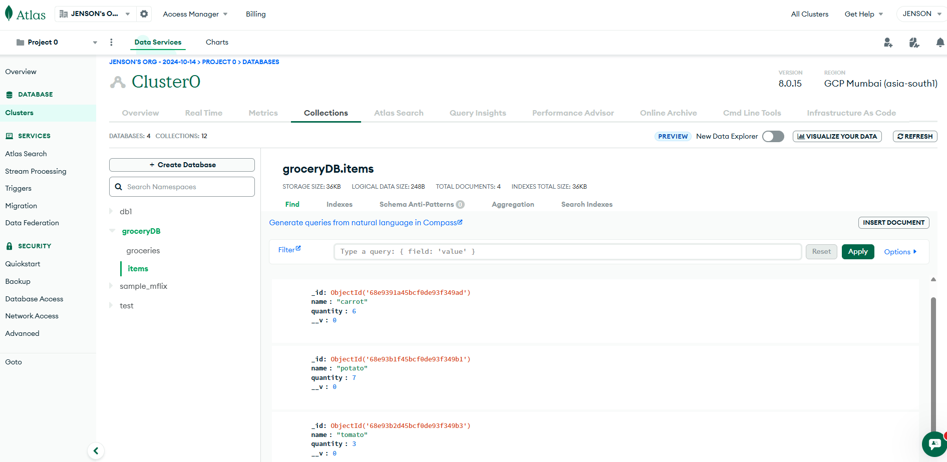

Render Hosting:
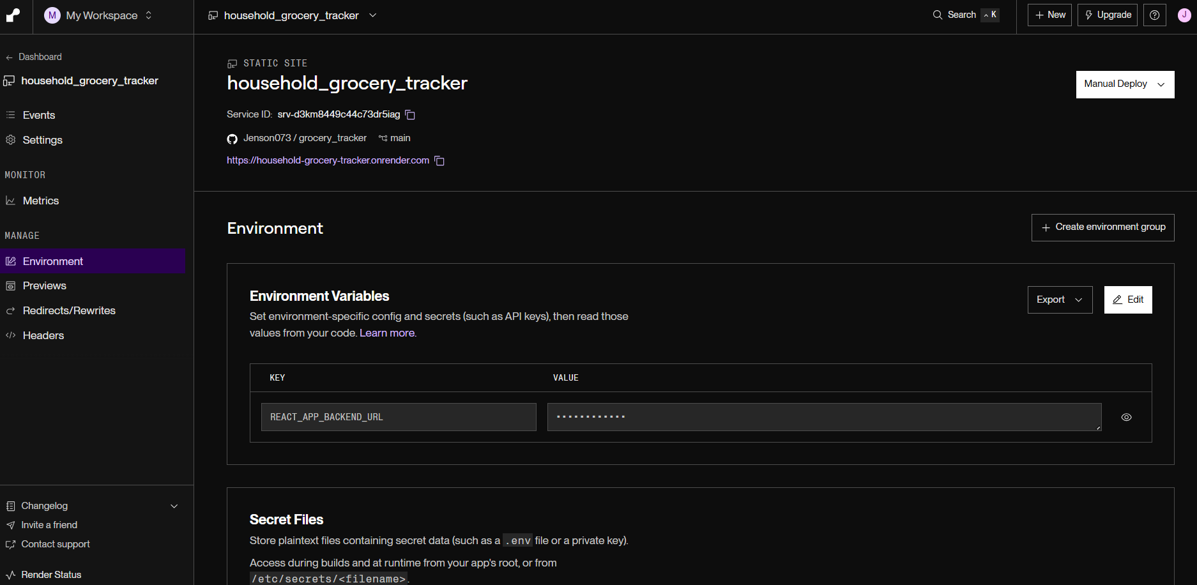

Screenshots:
